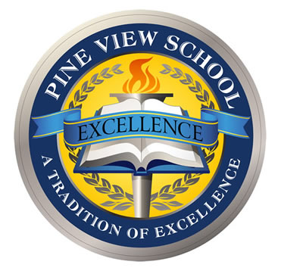
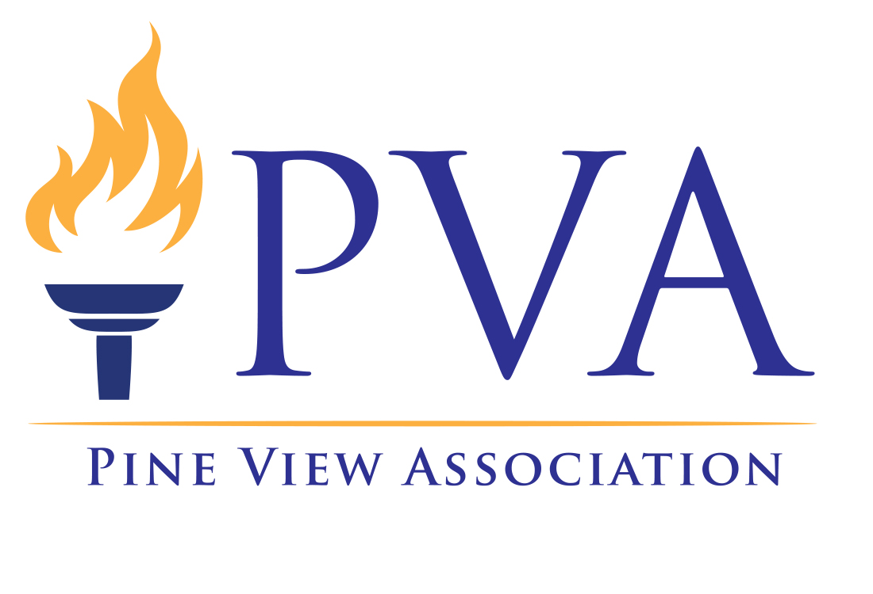
Pine View Association Annual Sponsorship Packages

Dear Pine View Sponsors,

Thank you for continuing your dedicated commitment during these tough times to support our mission to enhance and enrich Pine View students' school experience. All donations will continue to support academic, social, fine arts, and technology objectives to meet our goal to keep the whole Pine View experience alive.

Annual giving to the Pine View Association (P.V.A.) plays an exceedingly important role this year in shaping the education of our students and keeping the delicate infrastructure of academic classes and extracurricular experiences accessible for all students and adequately funded. Your gift to the P.V.A. will help to ensure an excellent learning environment with many opportunities for our students to discover and embrace their passion. No other school in our county and few in our state offer the exceptional experience that Pine View provides.

The support of involved parents and generous business partners like you makes our fantastic school events, programs, and initiatives happen, including:

- Award Winning Student Clubs like Speech & Debate, Model U.N. & H.O.S.A.
- Pine View Band & Pine View Peace Jam
- Hands-On Career Day
- Extra Aides and Counselors on campus
- Free agenda books for every student each year
- E-books library and Library Tablets
- Physical Education Equipment
- Expanded STEM equipment
- Software for the World Language Department
- Music and Art programs
- Pine View Pride and Proud Pythons
- Faculty and Staff Appreciation Week
- Pine View Fair
- Peramathon

Every gift counts, and the amount of your donation is a personal one. It is not about how much you give but that you believe in what Pine View does by participating. Your family or your business will be recognized in all our Pine Views publications, P.V.A. sponsored events throughout the school year, online, and, as soon as possible, on campus again.

Sincerely,

P.V.A. Sponsorship Committee

Pine View Association Annual Sponsorship 2020/2021 Packages

Family | Business  Bronze | Business  Silver | Business  Gold | Business Platinum
$500+ | $700+ | $2000+ | $3500+ | $6000+
Name on P.V.A. website  Thank You in PineViews  Recognition at P.V.A. events  Readathon: Names on the website  Peramathon: Name on T-shirt  Bonus: For a donation of $1500:  Featured in PineViews | Business logo on P.V.A. website  Thank You in PineViews  Recognition at P.V.A. events  PV Fair: Banner  Readathon: Name on website  Online Auctions/ Fundraising events: display on website  Peramathon: Name on T-shirt  Bonus: For a donation of $1000 and above:  Free Business Card Size Ad in all printed PineViews Issues 2020-2021 | Name or logo on P.V.A. website  Thank You in PineViews  Recognition at P.V.A. events  PV Fair: Banner  Readathon: Name on website  Online Auctions/ Fundraising events: display on website  Sponsor Recognition day: Pine View Website  Peramathon: Name on T-shirt  Free Business Card Size Ad in all PineViews Issues 2020-2021  Bonus: For a Donation of $3000 and above:  Upgrade to 1/4 Page Ads | Name or logo on P.V.A. website  Thank You in PineViews  Recognition at P.V.A. events  P.V. Fair: Banner, T-shirt, and T-signs  Readathon: Name on website  Online Auctions/ Fundraising events: display on website  Sponsor Recognition day: Pine View Website, and T-signs  Peramathon: Name on T-shirt, and T-signs  Free 1/4 Page Ad in all PineViews Issues 2020-2021  Bonus: For Donation of $4500 and above:  Upgrade to 1/2 Page Ads | Name or logo on P.V.A. website  Thank You in PineViews  Recognition at P.V.A. events  P.V. Fair: Banner, T-shirt, and T-signs  Readathon: Name on website  Online Auctions/ Fundraising events: display on website  Sponsor Recognition day: Pine View Website, and T-signs  Peramathon: Name on T-shirt, and T-signs  Free Full-Page Ad in all PineViews Issues 20-2021  .

8 PineViews Issue (4 Digital-Only* Versions)
Jul/Aug (Q1), Sep*, Oct (Q2), Nov*, Dec/Jan (Q3), Feb*, Mar (Q4), Apr/May*
Ads Per Issue Ads Sizes
Full Page Ad $700 7.5x10
½ Page Ad $350 7.5x5
¼ Page Ad $200 3.875x5
Business Card $125 3.875x2.5
Ads Deadline: 1st of prior month for each issue, Photos must be high resolution JPEG or PDF

Customize Options
**P.V.A. event sponsorship & underwriting items
**Reserved Parking Space
**Legacy Garden

- Contribution to P.A.C.E., Pinnacle Auction Donations, and P.V.A. Membership donations are not included in Annual Sponsorships.
- Community partners can create their sponsorship with "Give in-kind" services & goods.
- Please make checks payable to Pine View Association and mail it to 1 Python Path, Osprey FL 34229; alternatively, you can donate online at https://www.yourpva.org/donate/.

Pine View Association, Inc., is a 501(c)(3) organization (EIN 59-1390908), registered as a charitable organization with the State of Florida Department of Agriculture and Consumer Services (D.A.C.S.) license #CH4861. Prospective donors may visit the D.A.C.S. website (www.freshfromflorida.com) or toll-free hotline at 1-800-HELP-FLA (435-7352) to verify registration and financial information. A COPY OF THE OFFICIAL REGISTRATION AND FINANCIAL INFORMATION MAY BE OBTAINED FROM THE DIVISION OF CONSUMER SERVICES BY CALLING TOLL-FREE WITHIN THE STATE. REGISTRATION DOES NOT IMPLY ENDORSEMENT, APPROVAL, OR RECOMMENDATION BY THE STATE.

